Exercise 2 Report
Nguyen Tieu Phuong 20210692

Program source code & explanation
import paho.mqtt.client as mqtt
import json

BROKER = "broker.hivemq.com"
PORT = 1883
TOPIC = "tieuphuong/20210692"

message = {
"DeviceId": 11,
"packet_no": 126,
"temperature": 30,
"humidity": 60
}

def on_connect(client, userdata, flags, rc):
print(f"Connected with result code {rc}")
client.subscribe(TOPIC)

def on_message(client, userdata, msg):
print(f"Message received on topic {msg.topic}")
payload = msg.payload.decode('utf-8')
data = json.loads(payload)

print(f"Device ID: {data['DeviceId']}")
print(f"Packet No: {data['packet_no']}")
print(f"Temperature: {data['temperature']}°C")
print(f"Humidity: {data['humidity']}%")

client = mqtt.Client()
client.on_connect = on_connect
client.on_message = on_message

client.connect(BROKER, PORT, 60)

client.publish(TOPIC, json.dumps(message))
print(f"Published message: {json.dumps(message)}")

client.loop_forever()

• MQTT Connection Details: We specify the MQTT broker address (broker.hivemq.com), port number (1883), and the topic (tieuphuong/20210692) on which to publish and subscribe.
• Message Construction: The message is a Python dictionary containing fields like DeviceId, packet_no, temperature, and humidity. It is later converted into a JSON string for transmission.
• Callback Functions:
- on_connect: This function is called when the client successfully connects to the broker. It subscribes to the specified topic.
- on_message: This function is triggered when a message is received on a subscribed topic. The message is decoded and parsed from JSON format, and the individual fields are printed.
• MQTT Client Setup:
- We create an instance of the MQTT client.
- Attach the on_connect and on_message callback functions to handle connection and message events.
- The client connects to the broker and starts the loop to keep processing incoming and outgoing messages.
• Publishing a Message: The client.publish() method sends the JSON-formatted message to the specified topic.
• Subscription and Looping: After publishing the message, the client.loop_forever() method ensures that the program continues running and listens for incoming messages on the subscribed topic.

Running program:
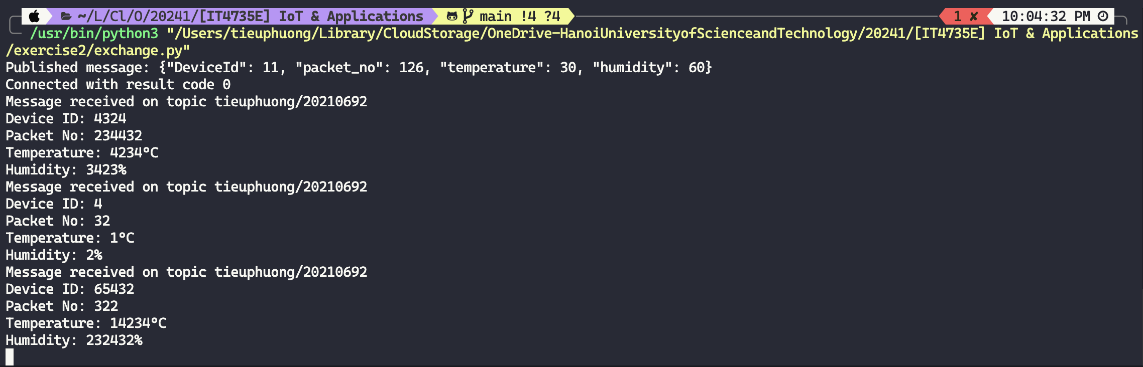

Confirm with MQTT client tool
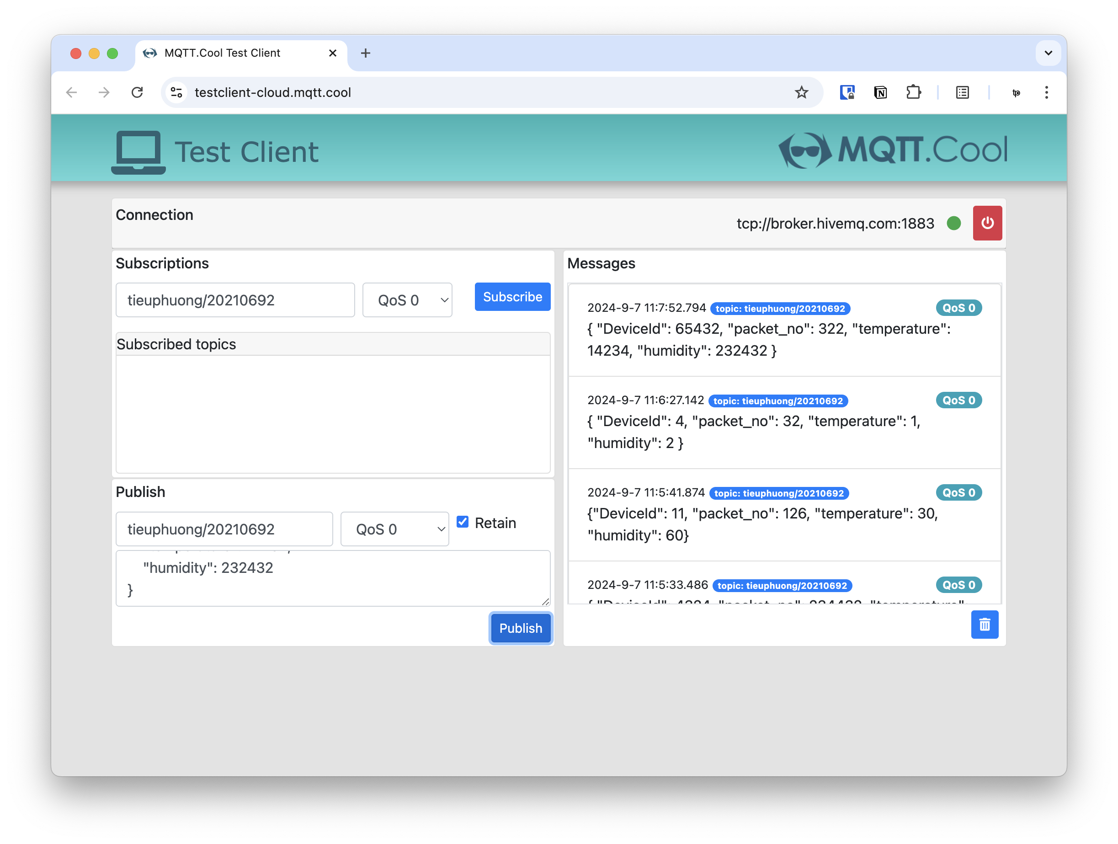
(Latest message on top was sent from the code. Due to Daylight Saving Time in where I’m at doing this assignment (Deakin Burwood Campus, Australia), the terminal did not account for that hence the 1-hour difference)

